Characterization Lab

Lab Exam Report

Common Base Amplifier

Sounak Mandal

19EC10088

Aim

The aim of the experiment is to determine the following in a Common Base Amplifier

1. Plot gain vs Frequency
2. Find out the bandwidth

Procedure

The following steps were carried out in order to determine the results:

1. The following data was already supplied for designing the circuit.
$$V_{CC}=12V and I_{CQ}=1mA$$

2. For maximum range of output, the output dc bias point should be at the
$$V_{out.dc}=\frac{V_{CC}}{2}=6V$$

3. This can be used to determine the collector resistance.
$$R_{C}=\frac{V_{CC}}{2I_{CQ}}=6kΩ$$

4. For stability purposes an emitter degeneration is used. We can assume that emitter degeneration drops 10% of the supply voltage across it.
$$R_{E}≈\frac{V_{E}}{I_{CQ}}=\frac{0.1V_{CC}}{I_{CQ}}=1.2kΩ$$

5. The voltage at the base can be approximated if we assume voltage drop across the junction is around 0.7V.
$$V_{B}=V_{E}+V_{BE}≈0.1V_{CC}+0.7=1.9V$$

6. The biasing resistances can then be determined from the base voltage if we assume that the base current is negligible as compared to the current flowing through the biasing circuit. We also
$$\frac{V_{cc}R_{4}}{R_{3}+R_{4}}=1.9 or \frac{R_{4}}{R_{3}+R_{4}}≈0.16$$

$$R_{3}+R_{4}=100kΩ$$

$$R_{4}= 16kΩ and R_{3}=85kΩ$$

7. The capacitor values are chosen as a standard value since it is sufficient that they behave as short circuit for the signal of interest. They are just coupling capacitors.
$$C_{1}=C_{2}=10μF$$

8. For the bode plot simply ac analysis was used after checking that the dc operating point puts the circuit in forward active region.

Observations and Circuit Diagram

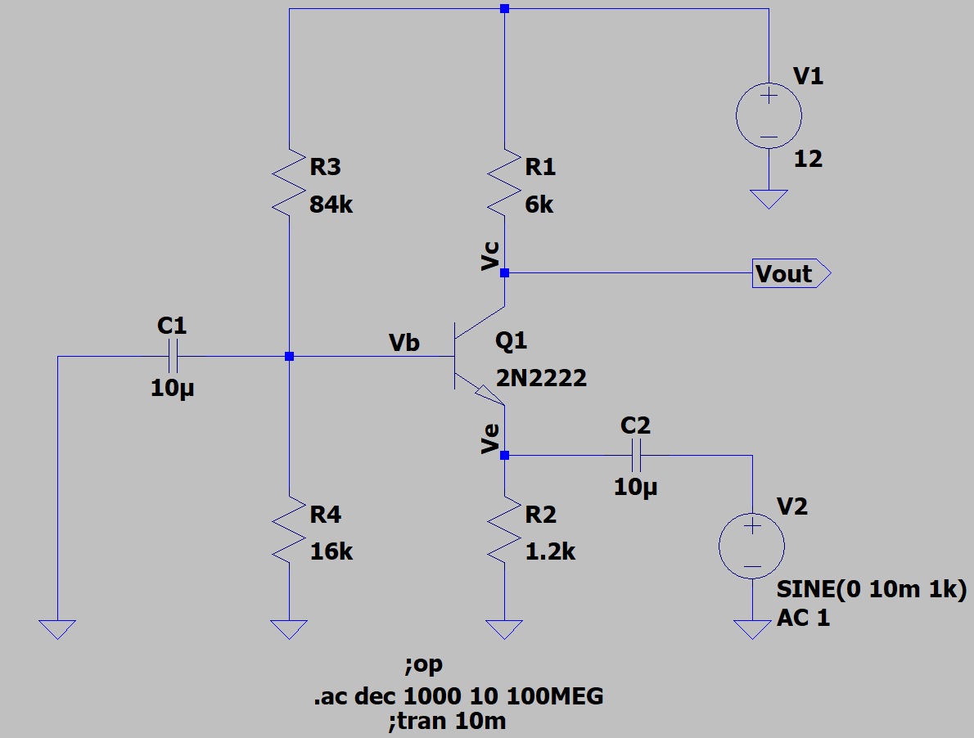

Circuit used for realisation of CB Amplifier

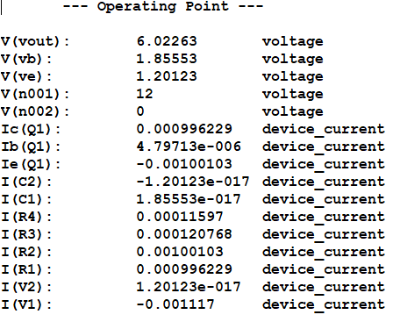

We can see that the dc voltage at collector (**6.022V**) is greater than the voltage at base (**1.855V**) making the CB junction reversed biased. The voltage at emitter (**1.201V**) is lower than the voltage at base making BE junction forward biased. The circuit is in forward active region.

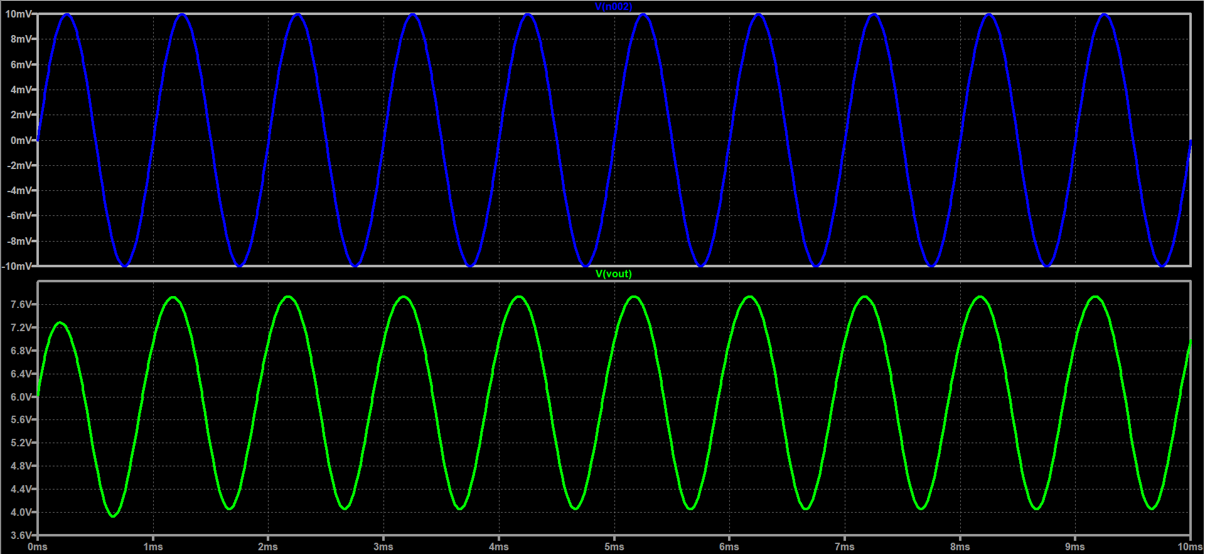

The transient output confirms that there is no clipping. So, the biasing is proper for the circuit.

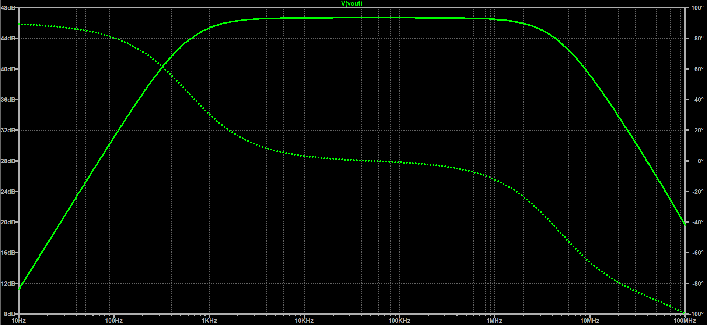

The bode plot is shown above. The gain obtained was 46.68 dB. The higher cutoff frequency obtained was 4.7 MHz and the lower cutoff frequency was obtained at 593Hz. Thus, the bandwidth is approximately 4.699 MHz.

Discussions

1. The amplifier is a non-inverting amplifier since the output and input voltage waveforms are in phase.
2. The amplifier has input and output impedance that do not suit for amplification. It has low input impedance and high output impedance, just opposite of what to expect from a voltage-voltage amplifier.
$$R_{in}=R_{E}||\frac{r_{o}+R_{c}||R_{L}}{1+g_{m}r_{0}}≈R_{E}||\frac{1}{g_{m}}≈\frac{1}{g_{m}}$$

$$R_{out}=R_{c}|\left|R_{L}\right||r_{o}≈R_{c}||R_{L}$$

3. The amplifier is unsuitable for driving low loads. This is under loaded conditions the load comes in parallel with the output resistance. If load is very low this will mean gain will drop significantly.
$$A_{V}=\frac{R_{c}||R_{L}}{\frac{1}{g_{m}}}=g_{m}(R_{c}||R_{L})$$

4. If the source is not ideal but has a series resistance then the gain would be modified since less of the signal now appears at the emitter. The gain drops by a significant amount.
$$A_{V}=g_{m}(R_{c}||R_{L})\frac{R_{E}||\frac{1}{g_{m}}}{R_{E}||\frac{1}{g_{m}}+R_{sig}}≈\frac{g_{m}(R_{c}||R_{L})}{1+g_{m}R_{sig}}$$

5. Due to very poor input output impedance, CB is mostly used for impedance matching between two stages, although the circuit has high gain.

Results

|  |  |
| --- | --- |
| Gain | 46.68 dB |
| Lower Cutoff Frequency | 593 Hz |
| Higher Cutoff Frequency | 4.7 MHZ |
| Bandwidth | 4.699 MHz |